The Five Strategies Framework for Research

Research is an important part of work in the ICT area, but ‘research’ is also a term which can be interpreted in various ways. In order to make research manageable and to define its meaning in the daily ICT practice, we use a research framework which fits well with the school projects and daily ICT practice in industry. FHICT chose to use the research framework of Turnhout et al (NIOC ‘013 & NordiChi 2014). The goal is to stimulate a good research attitude of both students and teachers. In this document we explain: (1) what we consider to be ‘research’ in the ICT field and (2) the framework we use.

# Applied Research

There are two types of research. On the one hand, **scientific research** is concerned with discovering new knowledge: setting up new hypothesis, proving theories, etc. On the other hand, **applied research** is concerned with using existing knowledge to solve problems in practice: Which programming language to use? What is the most suitable database backup style for this situation? How to make a web form with CSS? Which data should be used in our ERP system? Is this program fast enough? etc. As Fontys ICT is a University of Applied Sciences, in school projects as well as in internship and graduation projects we use applied research.

There are various strategies that can be used while doing applied research. Consider, for example, the following example. During an internship project, a student must decide on the most optimal Database Management system that will be used in the new system. Some of the research strategies that the student could use to solve this problem are:

1. Reading articles over Database Management Systems in books or on the Internet (Google, Forums, etc.). This type of strategy is called LIBRARY
2. Talking to experienced colleagues, and asking their opinion. This type of strategy is called FIELD.
3. Installing several types of Database Management Systems and testing them in order to measure which one is the easiest to use, the fastest, has the best backup system. This type of strategy is called LAB (laboratory).
4. Finding out which Database Management System is used in other departments, or in other companies with the similar problem. This type of strategy is called SHOWROOM.

Before getting to work, the student decides on the research ‘strategy’ - which methods he/she is going to use in the project.

During their internship and graduation projects, students should use various strategies (LIBRARY, FIELD, LAB and SHOWROOM) in different phases of the project. The student should also explain which methods (searching internet, interviewing colleagues, testing how fast the program works, etc.) were used. An example, which is taken from our student Marissa Intveld is shown below:

*After a LIBRARY and FIELD research we chose the concepts. An additional LIBRARY research was conducted where we looked at the educative games that are popular amongst the target audience (for detailed specification see “Appendix C”). This research looks into the mechanics and design of the games. After this a FIELD research was conducted with domain experts – brainstorm sessions were held about different concepts. As a result, three concepts were identified (see chapter “Concepts” for more details).*

# Research and Context

Applied projects (such as internship and graduation projects) are never entirely isolated from the rest of the world. There are always other similar projects, and professionals that dealt/solved similar problems. They can help you understand the situation. This is called the context. The context consists of 2 parts: *available work* and *application domain* (Figure 1).

The domain *available work* consists of existing artifacts, theories, models which you can have access to.

The *Application domain* is the context where the solution/product will be used. Most of the time we are talking here about the company you are providing a solution for.

Inbetween the domain *Available Work* and the *Application Domain* is the innovation space. This is the place where applied research takes place: inbetween both domains.

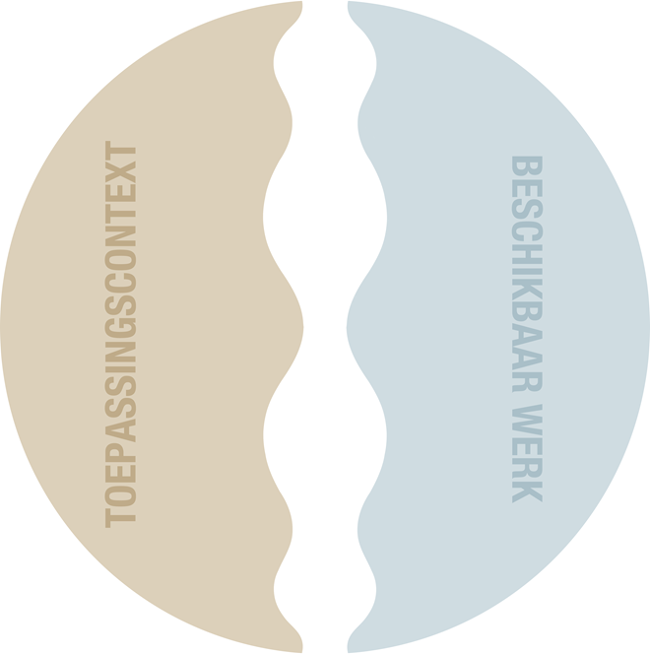

**Legend**‘Toepassingscontext’: application domain

‘Beschikbaar werk’: available work

Figure 1: A new product is related to *available work* and *application domain*

# The Five Research Strategies

This framework uses five strategies for answering (applied) research questions : Field, Library,Workshop, Lab(oratory) and Showroom. Each strategy consist of various research methods and techniques. Strategies LIBRARY and SHOWROOM are placed in the *available work* domain, and FIELD and LAB in *application domain*. WORKSHOP is placed centrally, as it is applicable to both contexts.

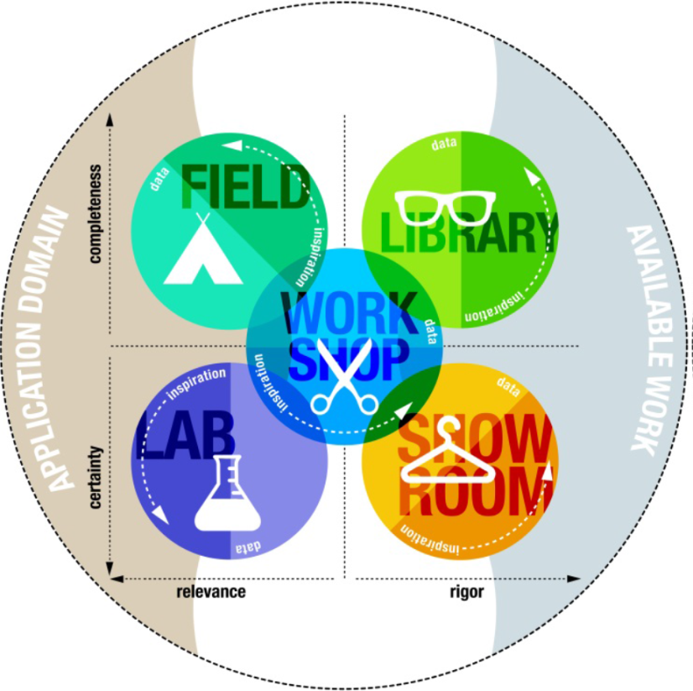

Figure2: The five research strategies



**FIELD.** The FIELD strategy is used to position your project in the applied area by looking at, searching, investigating the applied area. For example, one could hold interviews with experienced database experts in the company, analyse a successful database system of another department, observe endusers working with an application etc.

By researching the FIELD one can determine requirements of the product or simply get inspired. Various methods can be used for researching the FIELD. Some examples of methods for collecting data are: ‘conducting surveys’, ‘requirements engineering’ and ‘contextual analysis’. Examples of methods for inspiring methods are: ‘interviews’, ‘persona’s and ‘*cultural probes*’. Important purpose of FIELD research is gaining a complete and detailed idea about important aspects of user’s environment. Important values in this strategy are: “know your user” and “detailed and complete”.



**LIBRARY.** The LIBRARY strategy is used to investigate related/available work: which available work is reusable in your project. For example, you can investigate the known facts about colour blindness in order to use that information to build your website. Or which techniques can be used for local communication between two mobile devices? Which scripting languages are the best for communication with a certain database system?

The LIBRARY strategy also offers many research methods: reading books, related literature, internet blogs, forums, etc. Important issues here are ’literature overview’, ‘closely related to literature’, and ‘building upon earlier work’.

There is a lot to say about the LIBRARY research because references in applied research are often diverse, and therefore different than scientific research. While scientific researchers exclusively use references to reliable earlier work (reviewed articles in scientific journals, conferences, etc.). In applied research one often uses less reliable resources (namely internet blogs, forums, tutorials). Therefore, it is important to verify the resources used in applied research. The important values in this strategy are “on shoulders of giants” and “connect and enhance”



**WORKSHOP**.This strategy is placedcentrally on the schema.This strategy has to do with ‘hands-on’ experience. For example, implementing part of an application, designing a database, formulating a business advice, designing an organizational structure, etc. Sometimes the research task is focused on improving an existing solution, without considering the *available work* or *application domain*. For example, this strategy is suitable for a project where one uses many iterations to reach the end product step by step. During each new step or iteration new research questions or opportunities appear. Other strategies are then used in order to solve these new questions and opportunities. It is important to note that, only in exceptional projects only one strategy is used. In most projects it is necessary switch from one strategy to another in a high tempo. It is common to switch to other strategies from the WORKSHOP strategy, and therefore this strategy is positioned centrally between other strategies. A good example of a WORKSHOP research is incrementally improving the performance of a client-server application. A form study (where possible forms of a product are systematically explored), and making of *moodboards* are examples of intuitive approach within the WORKSHOP.

It is very important to execute this improvement in a methodological way while using the WORKSHOP strategy. During the form study, one can establish criteria (broad and thorough exploration), the process of finding a new solution can be documented or a development method as SCRUM or Prince can be used. The important values in this strategy are “improve your solution” and “explore and refine”.

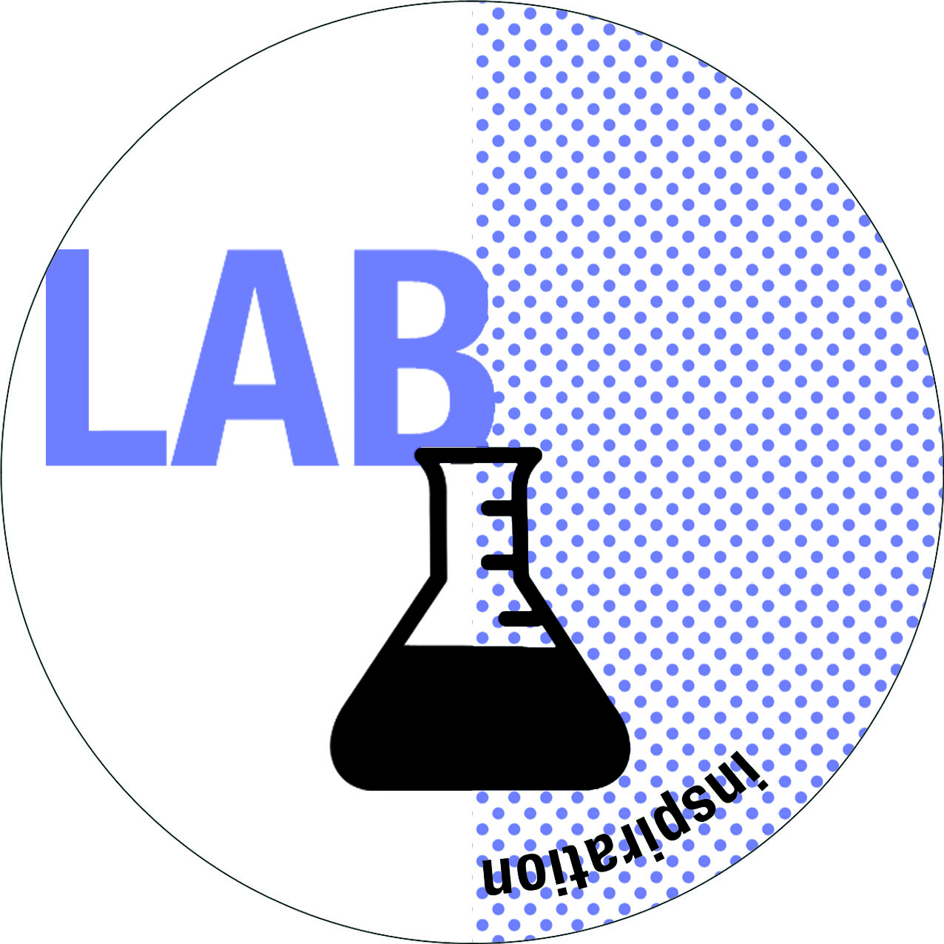

**LAB** (laboratory)**.** This strategy is used to test an aspect of your solution against an aspect of FIELD or LIBRARY. The LAB strategy zooms in in system parts and has a conclusive character (in contrast to the orienting character of FIELD and LIBRARY). The LAB studies aim to test (certainty) a proposed solution against the aspects of (or goals of) the *application domain* (relevance). One could, for example, test the details of an ICT product with formative user tests in LAB. Or, one could test the user experience when using a website, or technical tests of CPU usage of one piece of code. Also, most usability evaluations are LAB studies.

Within LAB strategy there are two types of methods. On the one hand, there are rational methods which are focused on data (e.g., testing the CPU or memory usage, the time needed to execute an algorithm, ect.). On the other hand, more intuitive methods are also used (some formative user tests). Important values in LAB are ‘precise and reliable’ and ‘to measure is to know’.



**SHOWROOM.** The SHOWROOM methods aim at positioning your project against other available work. For example, one could compare the performance parameters with the performance of other available systems (combination with LAB and/or LIBRARY strategies).

Important issues in the SHOWROOM strategy are ‘carefully compare’, ‘justify’, and ‘determine differences’. You will use the this strategy to find the answer to the question ‘why did you use this solution instead of other available solutions?’. The important values of the Showroom strategy are “show your value” and “position and define”.

# Conclusions

It is certain that you will use the five research strategies during school projects, internship project and graduation project. Using different strategies is called triangulation – approaching your research project from different points of view.

We use triangulation in order to get reliable and valid research results, and to get the full understanding of the situation at hand, and therefore, deliver a better product.

# References

|  |  |
| --- | --- |
| Referentie | name |
| Turnhout, K. van, Craenmehr, S., Holwerda, R., Menijn, M., Zwart, J.P en Bakker, R. (2013, April): **Triangulation: een basis voor de onderzoeksleerlijn in ICT- en Media-onderwijs. In *Proceedings van het NIOC congres 2013* (p. 277-286).** | NIOC ‘013 |
| Turnhout, K. van, Craenmehr, S., Holwerda, R., Menijn, M., Zwart, J. P., & Bakker, R. (2013, September). Tradeoffs in Design Research: Development Oriented Triangulation. In *Proceedings of the 27th International BCS Human Computer Interaction Conference* (p. 56). British Computer Society. | BSC HCI ‘013 |
| Turnhout, K. van, Craenmehr, S., Holwerda, R., Menijn, M., Zwart, J. P., & Bakker, R. (2014, September). De methodenkaart praktijkonderzoek. In: de Vries, E., Maes, R., Bronsgeest, W. (eds): De informatieprofessional 3.0. Academic Service ISBN 9789462450295). pp163-174 | Informatie Prof ‘014 |
| Turnhout, K. van, Bennis, A., Craenmehr, S., Holwerda, R.,Jacobs, M., Niels, R. Zaad, L., Hoppenbrouwers, S., Lenior, D., Bakker, R. (2014, Oktober). Design Patterns for Mixed-Method Research in HCI. In *Proceedings of the 9th Nordic Conference on Human-Computer Interaction: Fun, Fast & Foundational*. ACM, 2014. | NordiChi 2014 |